**Requirement Gathering and Analysis Phase**

**Data Flow Diagram & User Stories**

|  |  |
| --- | --- |
| Date | 07 July 2024 |
| Team ID | SWTID1720171927 |
| Project Name | Project – SB Foods-Food Ordering App |
| Maximum Marks | 4 Marks |

**Data Flow Diagrams:**

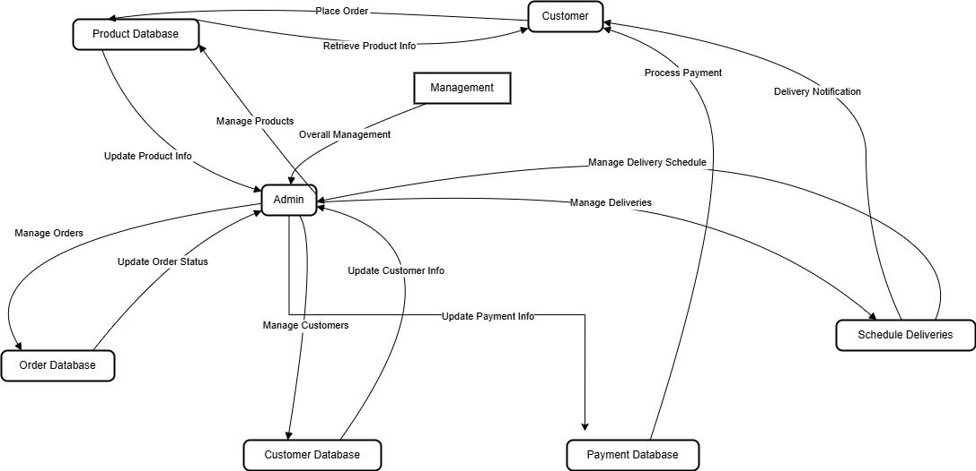

**User Stories:**

| **User Type** | **Functional Requirement (Epic)** | **User Story Number** | **User Story** | **Acceptance Criteria** | **Priority** | **Release** |
| --- | --- | --- | --- | --- | --- | --- |
| **Customer (Mobile user)** | Registration | USN-1 | As a user, I can register for the application by entering my email, password, and confirming my password. | I can access my account/dashboard. | High | Sprint-1 |
|  |  | USN-2 | As a user, I will receive a confirmation email once I have registered for the application. | I can receive the confirmation email & click confirm. | High | Sprint-1 |
|  |  | USN-3 | As a user, I can register for the application through Facebook. | I can register & access the dashboard with Facebook Login. | Low | Sprint-2 |
|  |  | USN-4 | As a user, I can register for the application through Gmail. | I can register & access the dashboard with Gmail Login. | Medium | Sprint-1 |
| **Customer (Mobile user)** | Login | USN-5 | As a user, I can log into the application by entering my email & password. | I can access my dashboard after logging in. | High | Sprint-1 |
| **Customer (Mobile user)** | Dashboard | USN-6 | As a user, I can view a personalized dashboard with my recent orders and favorite restaurants. | I can see my order history and favorite restaurants listed. | Medium | Sprint-2 |
|  |  | USN-7 | As a user, I can search for restaurants and food items. | I can see a list of restaurants and food items matching my search criteria. | High | Sprint-3 |
|  |  | USN-8 | As a user, I can add food items to my cart. | I can see selected food items in my cart. | High | Sprint-3 |
|  |  | USN-9 | As a user, I can place an order from the cart. | I can successfully place an order and receive a confirmation. | High | Sprint-3 |
|  |  | USN-10 | As a user, I can track my order status in real-time. | I can see the current status and location of my order. | Medium | Sprint-4 |
| **Customer (Web user)** | Registration | USN-11 | As a web user, I can register for the application by entering my email, password, and confirming my password. | I can access my account/dashboard. | High | Sprint-1 |
| **Customer (Web user)** | Login | USN-12 | As a web user, I can log into the application by entering my email & password. | I can access my dashboard after logging in. | High | Sprint-1 |
| **Customer (Web user)** | Dashboard | USN-13 | As a web user, I can view a personalized dashboard with my recent orders and favorite restaurants. | I can see my order history and favorite restaurants listed. | Medium | Sprint-2 |
|  |  | USN-14 | As a web user, I can search for restaurants and food items. | I can see a list of restaurants and food items matching my search criteria. | High | Sprint-3 |
|  |  | USN-15 | As a web user, I can add food items to my cart. | I can see selected food items in my cart. | High | Sprint-3 |
|  |  | USN-16 | As a web user, I can place an order from the cart. | I can successfully place an order and receive a confirmation. | High | Sprint-3 |
|  |  | USN-17 | As a web user, I can track my order status in real-time. | I can see the current status and location of my order. | Medium | Sprint-4 |
| **Customer Care Executive** | Customer Support | USN-18 | As a customer care executive, I can view and manage customer inquiries and issues. | I can access a dashboard to view and respond to customer inquiries. | High | Sprint-4 |
| **Administrator** | User Management | USN-19 | As an administrator, I can manage user accounts, including activating or deactivating them. | I can see a list of user accounts and change their status. | High | Sprint-3 |
|  | Restaurant Management | USN-20 | As an administrator, I can manage the restaurant listings and menu items. | I can add, edit, or remove restaurant listings and menu items. | High | Sprint-3 |